Bio-Inspired AI Audit of ChatGPT Using EMS-Inspired Scenarios
Final Project: Complete Audit + Video Demo
ITAI 4374: Neuroscience as Model for AI
Oscar Cortez & Judith Barrios
Group Project
May 6, 2026

Bio-Inspired AI Audit of ChatGPT Using EMS-Inspired Scenarios
Executive Summary
This final audit looks at ChatGPT through a neuroscience lens, using EMS-inspired scenarios to test how “brain-like” the system really is. We chose this approach because real emergency thinking is rarely clean or simple. Important details are often mixed in with distractions, emotions, uncertainty, and time pressure. Since our team has an EMS background, we wanted to test whether ChatGPT could separate urgent information from background noise and whether it could respond in a safe, organized way.
ChatGPT is a conversational AI system that can answer questions, summarize information, write text, explain concepts, and help organize plans. It can sound very human because its responses are fluent and structured. However, this audit asks whether that human-like language actually reflects brain-like behavior. The goal is not to prove that ChatGPT is a brain. The goal is to compare its behavior to brain-inspired functions from the course and identify where it performs well, where it falls short, and how it could be redesigned to work more safely and effectively.
We tested ChatGPT across five areas from the course: attention, memory, emotional salience, executive control, and learning from feedback. Each experiment used an EMS-inspired situation or a stressful decision-making scenario. We tested whether ChatGPT could identify urgent information in a messy prompt, remember important details across a conversation, recognize emotional or risky language, create a safe step-by-step plan, and revise its answer after being corrected.
The results showed that ChatGPT is strong at organizing language and following clear instructions. It did well when asked to identify urgent details, ignore distractions, and create a structured response. These strengths make it useful as a support tool for thinking through stressful situations. However, the system was weaker in areas that require real human experience. It can recognize emotional language, but it does not feel concern. It can track details in a conversation, but it does not form memories like a human brain. It can revise after feedback, but it does not truly learn from experience the way people do.
System Profile
The system audited in this report is ChatGPT, a conversational AI assistant developed by OpenAI. ChatGPT is built on large language model technology and is designed to respond to users through natural language. A user enters a prompt, and the system generates a response based on patterns learned from large amounts of training data. Depending on the version being used, ChatGPT can also work with images, files, voice, coding tasks, and other types of input.
The technical foundation behind systems like ChatGPT comes from transformer architecture. Transformers use attention mechanisms to process relationships between parts of an input. This allows the model to weigh certain words, phrases, or instructions more heavily than others. In that sense, the system has an attention-like process, although it is not the same as biological attention in the human brain. The Transformer model became a major foundation for modern AI because it allowed systems to process language more flexibly and effectively than older approaches.
For this audit, we did not test ChatGPT as a medical device or clinical authority. Instead, we used EMS-inspired scenarios because they are useful for testing brain-like functions. In real emergency work, a person has to pay attention, remember details, notice emotional cues, make decisions, and adjust when new information appears. These are all connected to topics from the course. That made ChatGPT a good system to audit through the lens of attention, memory, emotional salience, executive function, and feedback.
One major limitation of ChatGPT is that it does not have a body or lived experience. It cannot see a scene, hear breathing, notice skin color, smell smoke, feel heat, or sense urgency the way a person can. It can only respond to the information provided in the prompt. This is important because human intelligence is not only about language. The brain is connected to the body, emotions, memory, and the environment. ChatGPT can describe these things, but it does not experience them.
Experiment 1: Selective Attention in a Messy Scenario
The first experiment tested selective attention. In the brain, attention helps a person focus on what matters while ignoring distractions. This is especially important in EMS work because real situations are often messy. A patient may be scared, family members may be talking, background noise may be present, and the most important detail may be buried inside a lot of less important information.
For this experiment, we gave ChatGPT a written scenario that included both urgent and distracting details. The scenario described a person who was short of breath and confused. It also included less important details, such as what time the family ate dinner, background noise, and unrelated complaints. we asked ChatGPT to identify the most urgent concern and explain what mattered most. ChatGPT performed strongly in this experiment. It focused on the shortness of breath and confusion instead of getting distracted by the less important details. It treated those symptoms as urgent and recommended getting emergency medical help. It also organized the answer clearly, which made the response easy to follow.
This result shows that ChatGPT has a useful attention-like ability when working with language. It can identify important information in a prompt and give that information more weight than distractions. This resembles selective attention because the system does not treat every detail equally. However, this is still different from human attention. Human attention is connected to sensory input, emotion, fatigue, training, and experience. A trained responder may notice breathing effort, skin color, body position, or tone of voice before anyone explains what happened. ChatGPT cannot do that unless the user describes those details. It can filter written information, but it cannot scan a real environment.
Experiment 2: Working Memory and Detail Tracking
The second experiment tested working memory and memory-like behavior. In the human brain, working memory allows a person to hold information temporarily while using it. The hippocampus also helps form and organize new memories. In EMS-style situations, memory matters because details can change quickly. A responder may need to remember a patient’s age, symptoms, medications, allergies, timing, and changes in condition. For this experiment, we gave ChatGPT several details about a fictional patient. These included the patient’s age, main complaint, medication history, and one important safety concern. Then we asked an unrelated question to distract from the original details. After that, we asked ChatGPT to recall the important patient information and summarize it.
ChatGPT performed partially well. It remembered the major details from earlier in the conversation and used them to create a clear summary. This shows that the system can track context during a conversation. For a user, this is helpful because the conversation can build over multiple turns instead of starting over each time. The weakness is that this is not true biological memory. ChatGPT does not personally experience events. It does not encode memories through emotion, responsibility, or physical consequences. It also does not consolidate information like the hippocampus does in the human brain. If a conversation becomes too long or too cluttered, details can be lost, mixed up, or summarized incorrectly.
Experiment 3: Emotional Salience and Risk Recognition
The third experiment tested emotional salience. In the brain, the amygdala helps detect threat, fear, and emotionally important information. This matters in emergency situations because statements like “I can’t breathe,” “I feel like I’m going to die,” or “something is seriously wrong” should not be treated like ordinary conversation.
For this experiment, we gave ChatGPT a scenario where a person was scared, short of breath, and confused. The person also said they felt like something was seriously wrong. We wanted to see whether ChatGPT would recognize the emotional and safety importance of the statement or respond too casually. ChatGPT performed partially well. It recognized the situation as urgent and did not dismiss the emotional language. It recommended emergency evaluation and used calm, direct wording. This is important because a support tool should not minimize danger when a prompt suggests serious symptoms. The response showed an amygdala-like pattern because the system prioritized threat and urgency.
However, ChatGPT does not actually have an amygdala. It does not feel fear, concern, stress, or responsibility. It recognizes emotional language because it has learned patterns in text. That can still be useful, but it is not the same as human emotional processing. A human responder may feel urgency based on the scene, the patient’s appearance, the family’s reaction, or subtle changes in behavior. ChatGPT only knows what the user types into the prompt.

Experiment 4: Executive Control and Safe Planning
The fourth experiment tested executive control. The prefrontal cortex is connected to planning, decision making, self-control, organization, and goal management. These functions are important when a person has to follow steps, avoid unsafe choices, and adjust to constraints.
For this experiment, we asked ChatGPT to create a safe response plan for a stressful situation. The plan needed to be calm, step-by-step, and careful not to pretend the AI could diagnose or treat the person. we also asked it to separate immediate safety actions from general explanation. This tested whether the system could organize information while staying within safe limits. ChatGPT performed strongly in this area. It created a clear plan, prioritized emergency help, avoided overclaiming, and organized the information in a practical order. It also used language that was easy to understand. This shows strong planning ability because the system could manage several instructions at once.
The limitation is that ChatGPT does not have real agency. It can write a plan, but it cannot carry it out. It cannot check a pulse, call 911, move a patient, gather equipment, or notice whether the situation is getting worse. In the human brain, executive control is connected to action, emotion, consequences, and responsibility. ChatGPT’s planning ability is language-based. This experiment shows that ChatGPT can be valuable for organizing next steps and reducing confusion. It can help a person think through a situation more clearly. However, in high-stakes situations, the human user remains responsible for deciding what is accurate, safe, and appropriate.

Experiment 5: Feedback and Adaptation
The fifth experiment tested feedback-based adaptation. In the brain, dopamine is involved in reward, motivation, reinforcement, and learning from outcomes. When people receive feedback, they can adjust future behavior based on error and experience.
For this experiment, we asked ChatGPT to respond to a scenario in a professional but natural tone. Then we corrected it by saying the response sounded too generic and needed to reflect the perspective of someone with EMS experience. After that, we asked it to revise the answer and apply the same style to a new response. ChatGPT performed partially well. It accepted the correction and revised the response in a more specific and natural way. It also carried that feedback into the next answer within the same conversation. This makes ChatGPT useful for drafting, revising, and improving writing through back-and-forth feedback.
The limitation is that this is not biological learning. ChatGPT does not feel rewarded when it improves or embarrassed when it makes a mistake. It does not permanently rewire itself from one correction the way a person might learn from experience. It can adapt during a conversation, but that is not the same as deep learning from lived consequences.
Brain vs. AI Scorecard
Brain-Inspired Dimension | Rating | Justification
Selective Attention | Strong | ChatGPT can identify urgent details in a messy written scenario and ignore many distractions.
Working Memory | Partial | It can track details during a conversation, but it does not form biological memories like a human brain.
Emotional Salience | Partial | It recognizes risk and emotional language, but it does not actually feel fear, concern, or urgency.
Executive Control | Strong | It can organize safe step-by-step plans when the user gives clear instructions and limits.
Feedback Adaptation | Partial | It can revise based on correction during a conversation, but it does not permanently learn from one experience.
Embodiment | Missing | It has no body, senses, physical scene awareness, fatigue, pain, or motor feedback.
It can organize a response about a stressful situation, but it cannot experience that situation. That difference matters because users may trust the system more than they should if they only judge it by how fluent it sounds.
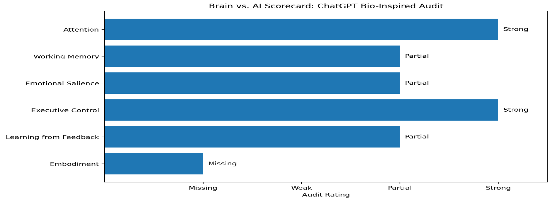
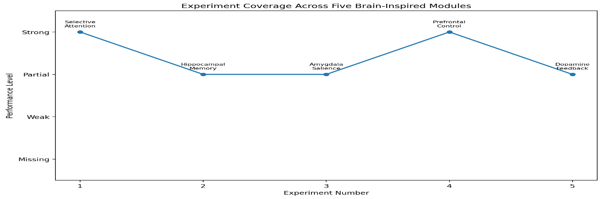
Brain-Inspired Redesign
If we could redesign ChatGPT using neuroscience principles, we would focus on making it safer, more context-aware, and more transparent. we would not try to make it exactly like a human brain. Instead, we would add brain-inspired systems that improve its support role while keeping humans in control.
First, we would add a hippocampus-like memory system. This would allow the AI to store important user-approved facts with dates, source notes, and confidence levels. It should also include a forgetting mechanism because outdated information can become confusing or unsafe. For EMS-inspired scenarios, this could help the system keep track of important context without mixing old details with current facts.
Second, we would add an amygdala-like risk detector. This module would scan for danger signs, emotional distress, and high-stakes topics before the final answer is produced. It would not make the AI emotional, but it would help the system slow down and respond more carefully when the situation involves safety, health, crisis language, or urgent decision making.
Third, we would add a prefrontal executive monitor. This system would check whether the AI followed instructions, stayed within its role, avoided overclaiming, and gave a safe response. In stressful prompts, this monitor could prevent the system from sounding too confident or acting like a replacement for professional care.
Fourth, we would add a thalamus-like attention gate. In the brain, the thalamus helps route and filter information. An AI version could help the system identify which parts of a messy prompt deserve the most attention. This would be useful when a user gives too many details and some are urgent while others are not.
Fifth, we would add a dopamine-like feedback loop. This would allow the system to learn user preferences and correction patterns in a controlled way. For example, if a user repeatedly asks for a more practical or less formal tone, the system could adapt. However, this would need safety limits so the AI does not learn unsafe habits or become too personalized in ways that reduce accuracy.
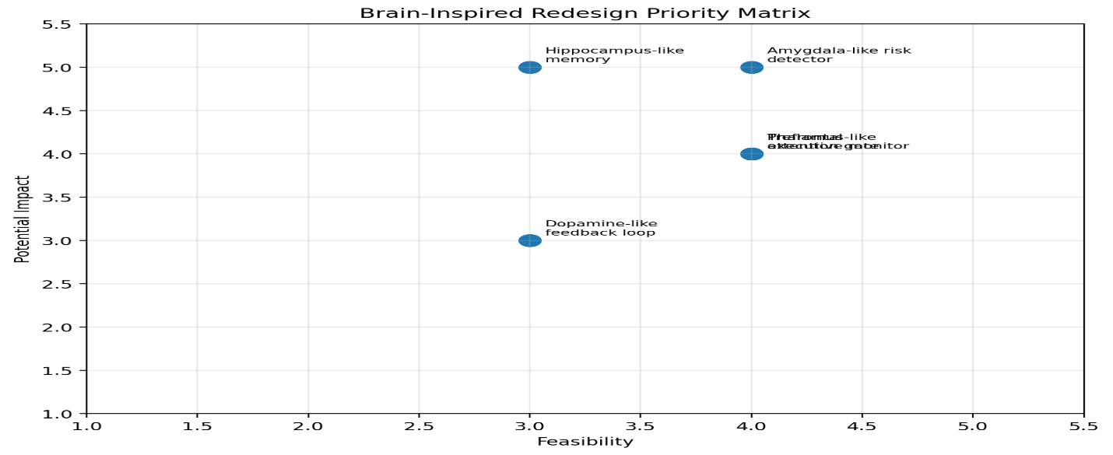
Together, these redesigns would make ChatGPT a stronger support tool. The goal would not be to replace human judgment. The goal would be to make the AI better at supporting attention, memory, safety, planning, and feedback while keeping humans responsible for final decisions.
Final Verdict
ChatGPT is impressive because it can take messy written information and turn it into something organized. In the EMS-inspired scenarios, it identified obvious risk, explained next steps, and adjusted its response when corrected. That makes it useful as a thinking and writing support tool. At the same time, this audit shows that ChatGPT is not brain-like in the deepest sense. It does not have a body, senses, emotions, lived experience, or real memory. It can support attention-like language processing and planning, but it should not replace human judgment. A more complete bio-inspired system would need memory consolidation, risk detection, executive self-monitoring, attention filtering, and safe feedback adaptation.

References
Hassabis, D., Kumaran, D., Summerfield, C., & Botvinick, M. (2017). Neuroscience-inspired artificial intelligence. Neuron, 95(2), 245–258.
OpenAI. (2024). Hello GPT-4o. OpenAI.
Vaswani, A., Shazeer, N., Parmar, N., Uszkoreit, J., Jones, L., Gomez, A. N., Kaiser, Ł., & Polosukhin, I. (2017). Attention is all you need. Advances in Neural Information Processing Systems, 30.

